PO Box 123 Drysdale Vic 3222 District 9780 Club 18227 Inc: A0017079H
www.drysdalerotary.org.au
Rotary Club of Drysdale Bulletin
BRUCE BANTER

No Meeting held on Monday 23 March 2020

President Report

- DG Roseanne has thanked the RC of Drysdale for the toiletries that were delivered to Swan Hill. A big thank you to Leila for collecting and providing lots of products.
- Art Show Raffle - Sell your tickets as soon as possible. Return books and money to Rae or Leila. Draw will take place as advertised.
- Helen Withers, partner of our newest member Ken is looking for charity based activities at the moment. If anyone has any ideas Please contact Helen on 0400 088 567.
- Friendship is alive and well
  - RC Drysdale has been in contact with many who have supported Rotary over the years. The aim was to make sure they are okay or in need of assistance. The Club has had several lovely replies thanking the Club for their offers and concerns. Good to know Friendship is still appreciated by our Community.
- Butt Project
  - DEWLP contacted the Club to determine the current status of the project given the Coranavirus situation. I was pleased to report that thanks to the work of David Anderson we are well placed to complete the project as planned. Following the Mr Butt day at the Bellarine Show and the earlier cleanup day with Portarlington Woofers and Walkers we now only have to install some permanent butt bins and distribute some personal butt bins. The installation may be able to be undertaken by one or two people if we observe social distancing so watch this space for further advice.
- Graffiti Clean up
  - I have purchased some more graffiti removal cleaners so if you are bored at home it might be the chance to undertake some more clean-ups. If you give me appropriate notice I can leave the materials outside the house for you to pick up and return. Unfortunately l think this is an activity to be carried out individually but we have time and an hour here and there will make a difference.
- Video Meetings
  - On Thursday night l participated in a video hook-up with DG Roseanne and other Presidents across the district. The discussion was about how to stay in touch with club members and run meetings using video links. It has been suggested that the platform Zoom be used as it is free (provided meetings last less than 40 minutes). In formation is available on the district web-site.
  - It was suggested that we start small and then build up to a full meeting. It was also discussed that the club should try to find someone to co-ordinate the move to electronic meetings. Any volunteers?
- District Assembly
  - As District Assembly has been cancelled there was discussion about the various training resources available and how they would be made available to those taking up office next year. Watch this space for more.

No Program
Despite the cancellation of the District Conference a few of our number still ventured up to Swan Hill for a getaway.

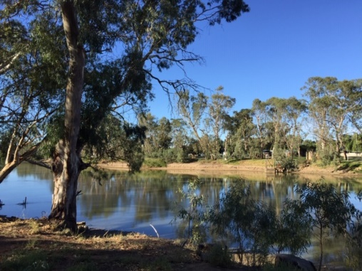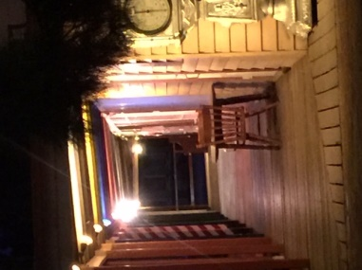

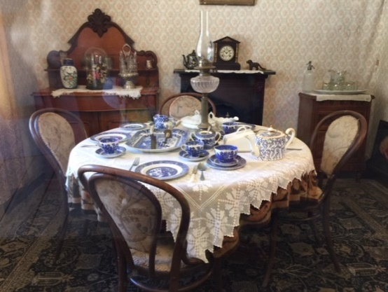

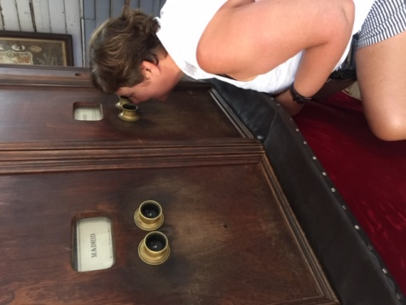

Powerball Confectionary Challenge – This week No 7 - Graeme Wise Last week No 20 – Jan Ward (Prize allocation suspended though unfortunately)
Foundation Flutter – tba

Upcoming meetings
March 30 CANCELLED
April 6 CANCELLED
April 13 No Rotary Meeting - Public Holiday
April 20 Behind the Badge – Gary Stenhouse (CSGC) Tentative only
April 27 Social Night not at CSGC) Details TBA Tentative only

President: Bruce Van Every Secretary: Caroline Rickard
Mob: 0409 149 025 Mob: 0408 989 221
Email: Vanevery4@telstra.com Email: caroliner.drysdale@ijh.com.au

Duty Roster 30 Mar – 13 Apr2020
Guest Speaker Liaison | WELCOME H/Tails | Attendance | Room set up/pack up | Sergeant
23 Mar | CANCELLED
30 Mar | CANCELLED
6 Apr | CANCELLED
13 Apr | CANCELLED

Community News and Important Dates

Rotary Club of Drysdale - Art Show Easter weekend ***CANCELLED****
9 -12 April

