PO Box 123 Drysdale Vic 3222 District 9780 Club 18227 Inc: A0017079H
www.drysdalerotary.org.au
Rotary Club of Drysdale Bulletin
BRUCE BANTER

Meeting held on Monday 20 January 2020 at the Clifton Springs Golf Club starting at 6.30pm

Apologies: James Charles, Leila Stecher, June Alexander, David Anderson, Sue (2) Harrold, Sue (3) Riminton, Mitchell Saffin, Gary Stenhouse, Jan Ward
Visitors: Chris Mann

Induction

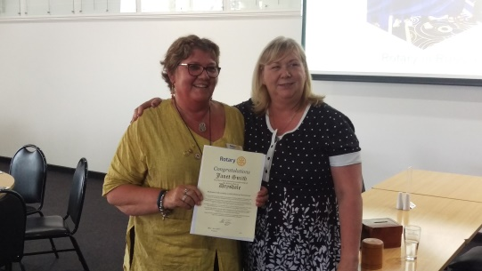
We welcomed our newest member Janet Smith into the Club with Bruce and Caroline lookin after the formalities.

Great to see that Janet has announced her ambition to unseat the current BBQ leadership in the future

President Report

- Geelong Group Rotary Clubs invited to participate in Victorian bushfire relief fundraiser. Rotary Club of Kardiinia is co-ordiating and are looking for members to attend the dinner and provide goods/services to be auctioned on the night. Club and Board to consider this event as part of its overall bushfire support plans
- Graffiti removal team of Bruce and David were in action again. A couple of Club members are under scrutiny for their claim that mortein fly spray is 100% effective in removing graffiti.
- Clifton Springs Primary School have gratefully accepted the Clubs offer to provide volunteers to assist students to improve their reading skills. Training will be provided and a working with children card is required. See Andrew Jeffrey if you are interested in participating
- Lyle gave Art Show update:
  - Leila and Rae will be co-ordinating raffle sales effort this year. As always ticker sellers are desperately needed from now until Easter. Please contact Rae on 0404893331 or email on malraemacleod@gmail.com if you can help out with the roster
  - T/shirts are available see previously circulated email or contact Lyle for details

Program – International Travel and Hosting Fellowships

Rotary International Fellowships are a group of Rotary members who share a common interest, most commonly recreational, vocational or sporting based. The group enables sharing of that common interest across international boundaries.

Our own Peter Downes is a passionate member of the International Travel and Hosting Fellowship (ITHF) and he spoke of his recent experience of a tour organised by the Fellowship in conjunction with the Rotary International World Conference in Russia.

The tour visited 4 major cities – Moscow, Kostrovo, Ivanova and St Petersburg. Peter showed us the many cultural highlights of the tour along with an interesting story on the development of the Rotary Organisation in Russia.
After its challenging origins there are now some 70 clubs with 3,000 members in Russia

Powerball Confectionary Challenge – Joint winners this week with No 11 coming up – Caroline and Rae.
Committee has agreed to present retrospective prizes to winners during recess period lucky recipients were – No 18 – Bruce and No 2 Andrew
Foundation Flutter – Gavan had the unpleasant task to report that the absolute certainty he had at Ballarat Greyhounds on Monday night was in fact not an absolute certainty. Over to Andrew Jeffrey to get us back on the winners list

Upcoming meetings
Jan 27 No Rotary Public Holiday
Feb 3 Member’s Talk: Martin Richards
Feb 10 Guest Speaker
Feb 17 The Annual Graeme Allison Memorial Foundation Night
Feb 24 Members Talk: Sue Riminton

President: Bruce Van Every Secretary: Caroline Rickard
Mob: 0409 149 025 Mob: 0408 989 221
Email: Vanevery4@telstra.com Email: caroliner.drysdale@ijh.com.au
Duty Roster 27 Jan–17 Feb 2020
Guest Speaker Liaison | WELCOME H/Tails | Attendance | Room set up/pack up | Sergeant
27 Jan No | Meeting | Australia | Day
3 Feb David | Sue R | Terry B | Sue H & Sue VE | Jan W
10 Feb Gavan | Catherine | Terry B | Gary and Colin B | Jan W
17 Feb Terry B | Rae | Terry B | Catherine & Martin | Jan W
24 Feb James | June A | Terry B | Glynis & Peter D | Jan W

Community News and Important Dates

Bellarine Springs – Central Road Clifton Springs
Open Day and Travel Expo
Thursday 13 February at 3:00pm

Festival of Glass Twilight Flames
The Range Curlewis – 1201 Portarlington Road Curlewis
Observe internationally renowned Venetian glass artist Mauro Bonaventure at work
Saturday 15 February at 7:00pm. $55 or $45 for sponsors

Drysdale Rotary Club – Social Night
A night at the Cinema and meal to follow - James Bond No 25 – No Time to Die
April – date to be confirmed

Geelong East Rotary Club – 50 Year Anniversary Dinner
The Range @ Curlewis 1201 Portarlington Road Curlewis
Two Course Meal $50 per person and drinks at bar prices
Bookings via https://www.trybooking.com/book/event?eid=588662&
Sunday 23 February 12:00 – 3:00pm

