PO Box 123 Drysdale Vic 3222 District 9780 Club 18227 Inc: A0017079H
www.drysdalerotary.org.au
Rotary Club of Drysdale Bulletin
BRUCE BANTER

Meeting held on Monday 2 March 2020 at Clifton Springs Golf Club starting at 6.30pm

Apologies: Bruce Van Every, James Charles, Glynis Jones, Sue (2) Riminton, Jan Ward, Sue (1) Van Every
Visitors: Ken & Helen Withers

President Report

- Public image workshop on Thursday 5 March – Branding Rotary
- Terry Baker reported that the distribution of Service Excellence Awards flyers to local businesses has started with help (or hindrance not sure yet) from Martin and Gary
- Suggestions invited for projects the club can launch for the 100th Anniversary of Rotary year in 2020/21
- Sue (2) Harrold’s Adventure Park play date went very well. A fantastic Friday morning of giant rides plus more leisurely floating activities were had by all. Due to the success of the initial outing there is talk of a follow up visit
- Thanks to the 10 members and partners who helped with the clean up day at Portarlington on Sunday
- The Bellarine Show will see the unveiling of the Miss Butts clean up promotion and we cant wait to see what that looks like
- Leila and Rae will be co-ordinating the Art Show raffle sales effort this year. As always ticket sellers are needed from now until Easter. Next priority is the Bellarine Show. Please contact Rae on 0404893331 or email on malraemacleod@gmail.com . If everyone does 2 sessions between now and Easter we should fill the roster
- Club still looking for a RYLA attendee – if you know any 18-25 year olds who would benefit from the personal growth and leadership program contact Leila
- Leila is doing some work on making up toiletry packs for Purple House (in aide of indigenous families in need). If you can assist please see Leila
- Gary is looking to kick off a Club footy tipping competition
- If you are interested in attending the Rotary District Conference in Swan Hill Friday night to Sunday lunchtime 20-22 March please let Sue Van Every know ASAP. Currently we have Bruce, Sue, Caroline, Graeme & Pat, Catherine & Alex going along.

Induction – Ken Withers
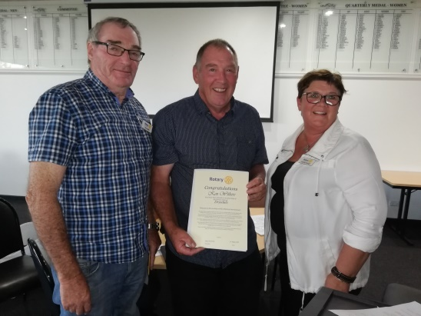
Our newest member Ken Withers was introduced by Terry with Caroline conducting the induction ceremony. Welcome aboard Ken.

Program – 100th Anniversary Projects

Some interesting ideas for a project to commemorate the 100th anniversary of Rotary International were aired at the meeting. Graeme Wise is interested in receiving more ideas before the Board settles on a short list later in the year.

Powerball Confectionary Challenge – last week – no 19 (OH NO NOT AGAIN MITCHELL!!) Winners are Lyle and Sue (2) Harrold. This weeks winner – No 2 – Andrew Jeffrey
Foundation Flutter – Andrew has reported a 100% loss on the foundation flutter. Next candidate is Glynis Jones
Heads and Tails won by Leila Stecher

Upcoming meetings
March 9 No Rotary Meeting Public Holiday Labour Day
March 16 Guest Speaker (CSGC)
March 23 Guest Speaker (CSGC)
March 30 Police Safety Awards at Leopold Sportspersons Club (Kensington Road Leopold) Joint meeting with Rotary Club of Bayside. Chair: Terry Baker
April 6 Art Show Briefing (Van Every Gallery for fine Arts – 16 Wintersun Crt. Gourmet pizzas – meal price $15
April 13 No Rotary Meeting - Public Holiday
April 20 Behind the Badge – Gary Stenhouse (CSGC)
April 27 Social Night not at CSGC) Details TBA

President: Bruce Van Every Secretary: Caroline Rickard
Mob: 0409 149 025 Mob: 0408 989 221
Email: Vanevery4@telstra.com Email: caroliner.drysdale@ijh.com.au
Duty Roster 9 - 30 Mar 2020
Guest Speaker Liaison | WELCOME H/Tails | Attendance | Room set up/pack up | Sergeant
9 Mar David | Sue R | Terry B | Sue H & Sue VE | Jan W
16 Mar Gavan | Catherine | Terry B | Gary and Colin B | Jan W
23 Mar Peter D | Rae | Terry B | Catherine & Martin | Jan W
30 Mar Terry | Sue H | Terry B | Graeme & Gary | Jan W

Community News and Important Dates

Rotary District Conference
Swan Hill
20-22 March

Victorian Bushfire Recovery Dinner Dance and Auction
Rotary Clubs of Greater Geeong
Capri Receptions – 258 Pakington St Geelong West
6:30 – 7:00. Cost $65 per head or $650 for table of 10
Friday 3 April 2020

Rotary Club of Drysdale - Art Show Easter weekend
9/4 Thursday Set up Time: TBA by Lyle
10/4 Friday 9.30 - 3.00 receiving paintings and hanging paintings
10/4 Friday night opening - Artists, Sponsors, Rotarians, Judge Winners announced
11/4 Saturday Sales and viewing
12/4 Sunday Dinner after the Art Show clean up

Australian Golfing Fellowship 42nd Annual Golf Carnival
Hosted by Rotary Club of Highton
Thirteenth Beach Course at Barwon Heads
More details at www.gagfr.org.au
19 – 24 April 2020

Drysdale Rotary Club – Social Night
A night at the Cinema and meal to follow - James Bond No 25 – No Time to Die
April – date to be confirmed

Shelterbox Tasmania Trek 2020
On this adventure, you’ll spend five-days trekking a variety of trails around the Cradle Mountain Village area. From easy exploration walks to day-long hikes up to lookouts, you’ll discover the Tasmanian wilderness up close on this unforgettable adventure. Best of all, you’ll raise funds to support ShelterBox Australia on their mission to help families rebuild their lives after a disaster More information available from: info@inspiredadventures.com.au
7 – 11 November 2020

