PO Box 123 Drysdale Vic 3222 District 9780 Club 18227 Inc: A0017079H
www.drysdalerotary.org.au
Rotary Club of Drysdale Bulletin
BRUCE BANTER

Meeting held on Monday 10 February 2020 at Bellarine Springs Retirement Village starting at 6.30pm

Apologies: Colin Bartlett, James Charles, Andrew Jeffrey,
Visitors: Geoff Morphett (RC Highton – Kardinia), Leigh Morley, Bellarine Springs Management and staff

President Report
- The Club was well represented with the jumping castle at Torquay on the weekend with Colin H, Bruce and Sue, Gary and Bard, Terry and Shirley looking after it
- Leila and Rae will be co-ordinating the Art Show raffle sales effort this year. As always ticket sellers are desperately needed from now until Easter. Please contact Rae on 0404893331 or email on malraemacleod@gmail.com if you can help out with the roster. Also please return sold individual ticket allocations as soon as possible please

Program – Bellarine Springs
The Club enjoyed the hospitality of the Bellarine Springs Retirement Village on Monday night.
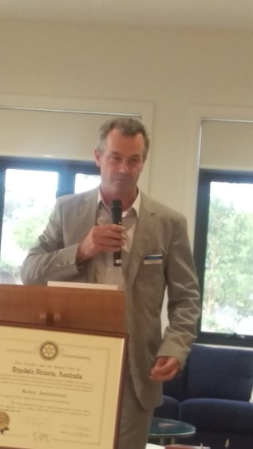
The CEO of Pinnacle Living who operate a number of retirement villages gave us a run down on his journey and that of Bellarine Springs.
After completing secondary school Geoff was advised by his parents that careers involving manual labour were to be avoided and had some initial interest in being a Pilot. The restructure of the aviation industry put a dampener on that and he then looked to something in Engineering. On graduating Geoff joined Vicroads in their Work Experience program and as luck would have it worked in our own Lyle Grinter’s program (jury is still out on whether Geoff’s career flourished because of or in spite of that experience)
A move to major contracting firm Thiess saw him work on a range of high profile projects – Albert Park Grand Prix Circuit, Torrumbarry Weir, Roxby Downs and the MCG footbridge.
After 10 years Geoff wanted to operate a business of his own and saw an opportunity when the Tudor Village retirement village in Lillydale came up for sale in 2003
In 2006 the business grew with the building of a second village in Balwyn, and in 2007 the purchase of the land parcel now occupied by Bellarine Springs.
The 2008 Global Financial Crisis was a challenging time for the business but it has come out from those times to establish the current 120 houses with plans for another 130 in the coming years.
The business prides itself on providing high quality accommodation and services in its villages which was certainly evident during our visit

Powerball Confectionary Challenge – No 17 Geoff Ross
Foundation Flutter – Andrew Jeffrey (results not available at time of going to press)
Heads and Tails won by Shirley Baker
Bellarine Springs Lucky Draw won by Glynis Jones
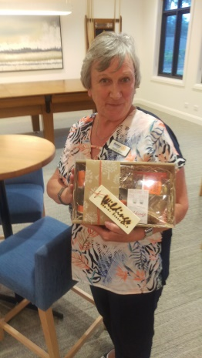

Upcoming meetings
Feb 17 The Annual Graeme Allison Memorial Foundation Night (GSCG 6:00 for 6:30)
Guest presenter Alison Davis ‘It takes a Village’ on her work in the Solomon Islands
Feb 24 Rotary’s 115th Birthday (CSGC 6:00 for 6:30)
Members Talk: Sue Riminton Behind the Badge Members Talk.
Special Guest: Toby Roberts, The Science Experience student
March 2 To be confirmed at CS Golf Club
March 9 No Rotary Meeting Public Holiday Labour Day
March 16 TBA
March 23 Police Safety Awards at Leopold Sportspersons Club Joint meeting with Rotary Club of Bayside. Chair: Terry Baker.
March 30 TBA
April 6 Art Show Briefing (Van Every Gallery for fine Arts – 16 Wintersun Crt. Gourmet pizzas – meal price $15
April 11-12 Art Show Friday night, Saturday, Sunday Easter weekend
9/4 Thursday Set up Time: TBA by Lyle
10/4 Friday 9.30 - 3.00 receiving paintings and hanging paintings
10/4 Friday night opening - Artists, Sponsors, Rotarians, Judge
- Winners announced
12/4 Sunday Dinner after the Art Show clean up

President: Bruce Van Every Secretary: Caroline Rickard
Mob: 0409 149 025 Mob: 0408 989 221
Email: Vanevery4@telstra.com Email: caroliner.drysdale@ijh.com.au
Duty Roster 17-24 Feb 2020
Guest Speaker Liaison | WELCOME H/Tails | Attendance | Room set up/pack up | Sergeant
17 Feb Terry B | Rae | Terry B | Catherine & Martin | Jan W
24 Feb James | June A | Terry B | Glynis & Peter D | Jan W

Community News and Important Dates

Bellarine Springs – Central Road Clifton Springs
Open Day and Travel Expo
Thursday 13 February at 3:00pm

Festival of Glass Twilight Flames
The Range Curlewis – 1201 Portarlington Road Curlewis
Observe internationally renowned Venetian glass artist Mauro Bonaventure at work
Saturday 15 February at 7:00pm. $55 or $45 for sponsors

Geelong East Rotary Club – 50 Year Anniversary Dinner
The Range @ Curlewis 1201 Portarlington Road Curlewis
Two Course Meal $50 per person and drinks at bar prices
Bookings via https://www.trybooking.com/book/event?eid=588662&
Sunday 23 February 12:00 – 3:00pm

Visit to the Adventure Park Wallington
Anyone who would like to join a group of adults wanting to go to have a ride on the Tsunami at the water park and have fun should meet at the Adventure Park on the. This will be weather dependant. If it is too wet and cold the group will be visiting the cider place across the road.”
28th Feb at 10am

Rotary District Conference
Swan Hill
20-22 March

Drysdale Rotary Club – Social Night
A night at the Cinema and meal to follow - James Bond No 25 – No Time to Die
April – date to be confirmed

Shelterbox Tasmania Trek 2020
On this adventure, you’ll spend five-days trekking a variety of trails around the Cradle Mountain Village area. From easy exploration walks to day-long hikes up to lookouts, you’ll discover the Tasmanian wilderness up close on this unforgettable adventure. Best of all, you’ll raise funds to support ShelterBox Australia on their mission to help families rebuild their lives after a disaster More information available from: info@inspiredadventures.com.au
7 – 11 November 2020

