PO Box 123 Drysdale Vic 3222 District 9780 Club 18227 Inc: A0017079H
www.drysdalerotary.org.au
Rotary Club of Drysdale Bulletin
BRUCE BANTER

Meeting held on Monday 17 February 2020 at Clifton Springs Golf Club starting at 6.30pm

Apologies: James Charles, Mitchell Saffin, Jan Ward
Visitors: ADG Judy Beasley, (RC Essendon – Roger Leske, Maria Coupis, Colin Styles), Rose Allison, Yannick, M Jeffrey, Alex Jeffrey

President Report
- The cigarette butt receptacles planned for installation around the bay were shown to the club
- Caroline represented the Club at the Festival of Glass. The club sponsors 4 awards at the festival
- Colin B reported on an incident free and profitable weekend BBQ.
- Leila and Rae will be co-ordinating the Art Show raffle sales effort this year. As always ticket sellers are needed from now until Easter. Please contact Rae on 0404893331 or email on malraemacleod@gmail.com . If everyone does 2 sessions between now and Easter we should fill the roster
- ADG – Judy Beasley have a run down on activities and news from District 9780. Of particular note is that the Club is looking to sponsor a participant or two at this years RYLA program. RYLA is a leadership and personal growth weeklong retreat for 18-25 year olds.

Royce Abbey Award
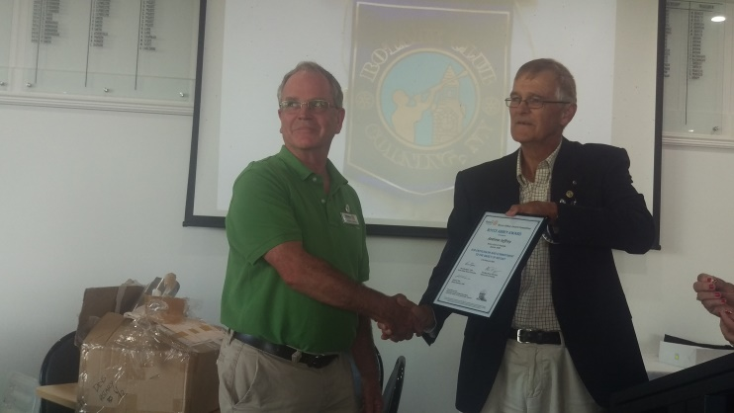
RC of Essendon representatives, Roger and Maria gave an introduction to the Award and its origins. The program provides educational opportunities in agriculture based disciplines to young adults from developing countries. Funding is derived from Rotary Clubs and other organisations contributing $1,000 per award presentation.
RC Drysdale has been a strong supporter of the program over the years and this year presented a Royce Abbey award to Andrew Jeffrey for his impressive work on club activities since joining us.

Foundation
Foundation Committee Chair Sue (1) gave a summary of the Foundation, starting with a tribute to former member Graeme Allison who was a staunch supporter of the charitable arm of Rotary.

Program – Alison Davis - ‘It takes a Village’
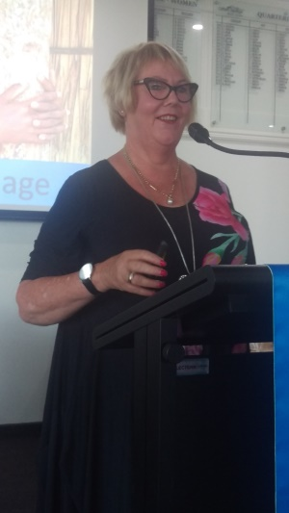
Alison spoke of her experiences working in the Solomon Islands as a literary advisor to the Government. The overriding learning Alison took from this experience was that giving people aid doesn’t fix problems – helping people help themselves gets things done.

There are significant social problems in the Solomon Islands:
- 70% of females attend primary school but only 7% attend secondary school. The reasons – cost, gender violence, lack of toilet facilities, under age marriage
- 1% of the population speaks English however the education curriculum is required to be delivered (including exams) in English
- The family unit is particularly strong and some 97% identify as being of Christian faith. Paradoxically, however, disputes and complaints are often not dealt with by the judicial system rather resolved by swift application of local ‘justice’ often with a bush knife.
- Forestry accounts for some 80% of council revenue however harvesting is occurring at 20 times the sustainable rate
- Mining is also a major industry operated by foreign nationals with major environmental concerns arising – along with the extent of that foreign influence

Despite these problems Alison saw great optimism for the future based on her experience with the community at Borana.

In Borana the children attend school regularly, eat healthy locally produced food, have access to medical supplies and have initiated adult literacy programs. They have initiated a tourism industry based around the WWii battle of Guadalcanal and are developing eco-tourism focussing on fishing activities. A great example of helping people help themselves.

Powerball Confectionary Challenge – No 3 –Graeme Allison memorial number (how appropriate on Foundation night) and David Anderson
Foundation Flutter – Andrew Jeffrey (results not available at time of going to press)
Heads and Tails won by Andrew Jeffrey

Upcoming meetings
Feb 24 Rotary’s 115th Birthday (CSGC 6:00 for 6:30)
Members Talk: Sue Riminton Behind the Badge Members Talk.
Special Guest: Toby Roberts, The Science Experience student
March 2 To be confirmed at CS Golf Club
March 9 No Rotary Meeting Public Holiday Labour Day
March 16 TBA
March 23 .
March 30 Police Safety Awards at Leopold Sportspersons Club Joint meeting with Rotary Club of Bayside. Chair: Terry Baker
April 6 Art Show Briefing (Van Every Gallery for fine Arts – 16 Wintersun Crt. Gourmet pizzas – meal price $15

Works from Festival of Glass – Artist in Residence
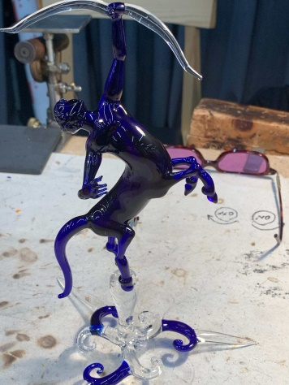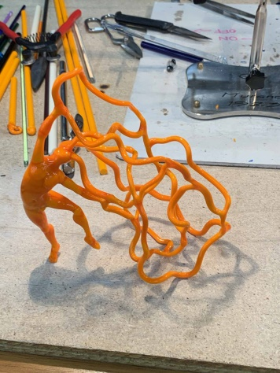

President: Bruce Van Every Secretary: Caroline Rickard
Mob: 0409 149 025 Mob: 0408 989 221
Email: Vanevery4@telstra.com Email: caroliner.drysdale@ijh.com.au

Duty Roster 24 Feb - 23 Mar 2020
Guest Speaker Liaison | WELCOME H/Tails | Attendance | Room set up/pack up | Sergeant
24 Feb James | June A | Terry B | Glynis & Peter D | Jan W
2 Mar Jan W | James | Terry B | Lyle G & Peter D | Jan W
9 Mar David | Sue R | Terry B | Sue H & Sue VE | Jan W
16 Mar Gavan | Catherine | Terry B | Gary and Colin B | Jan W
23 Mar Peter D | Rae | Terry B | Catherine & Martin | Jan W

Community News and Important Dates

Geelong East Rotary Club – 50 Year Anniversary Dinner
The Range @ Curlewis 1201 Portarlington Road Curlewis
Two Course Meal $50 per person and drinks at bar prices
Bookings via https://www.trybooking.com/book/event?eid=588662&
Sunday 23 February 12:00 – 3:00pm

Visit to the Adventure Park Wallington
Anyone who would like to join a group of adults wanting to go to have a ride on the Tsunami at the water park and have fun should meet at the Adventure Park on the. This will be weather dependant. If it is too wet and cold the group will be visiting the cider place across the road.”
28th Feb at 10am

Rotary District Conference
Swan Hill
20-22 March

Victorian Bushfire Recovery Dinner Dance and Auction
Rotary Clubs of Greater Geeong
Capri Receptions – 258 Pakington St Geelong West
6:30 – 7:00. Cost $65 per head or $650 for table of 10
Friday 3 April 2020

Rotary Club of Drysdale - Art Show Easter weekend
9/4 Thursday Set up Time: TBA by Lyle
10/4 Friday 9.30 - 3.00 receiving paintings and hanging paintings
10/4 Friday night opening - Artists, Sponsors, Rotarians, Judge Winners announced
11/4 Saturday Sales and viewing
12/4 Sunday Dinner after the Art Show clean up

Drysdale Rotary Club – Social Night
A night at the Cinema and meal to follow - James Bond No 25 – No Time to Die
April – date to be confirmed

Shelterbox Tasmania Trek 2020
On this adventure, you’ll spend five-days trekking a variety of trails around the Cradle Mountain Village area. From easy exploration walks to day-long hikes up to lookouts, you’ll discover the Tasmanian wilderness up close on this unforgettable adventure. Best of all, you’ll raise funds to support ShelterBox Australia on their mission to help families rebuild their lives after a disaster More information available from: info@inspiredadventures.com.au
7 – 11 November 2020

