PO Box 123 Drysdale Vic 3222 District 9780 Club 18227 Inc: A0017079H
www.drysdalerotary.org.au
Rotary Club of Drysdale Bulletin
BRUCE BANTER

Meeting held at various abodes around the Bellarine joined by the magic of ZOOM on Monday 11 May 2020 – week 8 of our isolation

Apologies: Colin Bartlett, Janet Smith, James Charles, Garry Stenhouse

President Report

- District News
  - Next year officer bearers in particular to note but all Rotarians in the club are invited to tune into the Online District assembly sessions to learn more about Rotary
  - Our own James Charles is a guest speaker at the Assembly and will be appearing at 7.25pm on 25 May
  - There will be no youth exchange programs conducted this year
  - Sad news has come through that long time stalwart of the Districts RAWCS program Anton Van Dornick has had to resign due to ill health
  - Various District 9 and 10 Clubs have contributed $14,500 in health related projects. There are discussions amongst District and Clubs on how best to collaborate to ensure funding and support is applied as widely as possible in the current environment
  - There is a meeting on 21 May to discuss opportunities for the individual Club collaboration on the development of project(s) to make the 100 year anniversary of Rotary. NB. We expect the Club to develop its own project in addition to what comes from this forum
  - Incoming DG partners project for 2020/21 is support of the Indigenous Literacy Foundation
  - A online forum on District insurance requirements is on 13 May at 5.30 – our ever efficient Secretary Caroline is going to tune in to that one
  - District changeover is an online event scheduled for 28 June
- Adrian Mannix Awards
  - The Adrian Mannix community service award program is on again. Graeme and Sue 1 will represent the Club on the deliberations. The award ceremony is scheduled for 20 May (online event)
- Club Changeover Meeting
  - Changeover is being planned to be by ZOOM. Any suggestions on how to make it memorable welcome – please pass on any thoughts to Bruce.
  - 2020/21 DG visits to clubs will be via ZOOM and will be scheduled to commence after August 3.
- Australian Rotary Health Research
  - Catherine is looking at a fund raising initiative whereby Rotarians (or others) sign up to a ‘puzzle package’ with a proportion of the fee ($12) going back to the Club and a further $12 going to ARHR. A flyer/application form is in development phase with Leila and Sue 3 lending a hand
- Hand Sanitiser
  - The Club bought a significant quantity of sanitiser from the local business, The Whiskery, who is now making whiskey, gin and hand sanitiser (during pandemic). The supply has been delivered to the local Medical Centre.
- RI World Convention
  - is on from 20-26 June as an online event. This format gives many rotarians to experience a world convention for the first time

Program
Colin’s mastery of the IT world was on display again. We watched a 15 minute video on the origins of what is now known as the End Polio campaign. The historical content was a stark reminder of how widespread polio was until the development of effective vaccines in the 1950s. With only small pockets of the wild polio virus still present in the world the success of the program has been truly remarkable, but unfortunately there is still work to be done to achieve the total elimination of the virus.
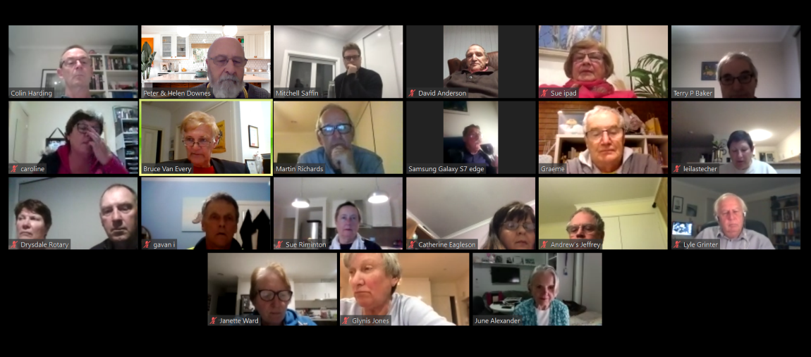
Look familiar?

Powerball Confectionary Challenge –
Suspension week 1 - No 7 - Graeme Wise, Week 2 No 20 – Jan Ward, week 3 No 18 – Bruce Van Every, Week 4 No 11 – Joint winners – Caroline and Rae, week 5 No 18 – Bruce Van Every, Week 6 – No 2 – Andrew Jeffrey, Week 7 – No 10 – Sue Van Every, Week 8 - No 10 – Sue Van Every again!!
Week 9 to be announced with fanfare and ceremony next week

(Prize allocation suspended though unfortunately)
Foundation Flutter – Caroline has invested in home made quince paste – contactless pickup for $2 a tub from Carolines
Heads and Tails won by Peter Downes

Upcoming meetings
May 18 ZOOM meeting
May 25 ZOOM meeting

President: Bruce Van Every Secretary: Caroline Rickard
Mob: 0409 149 025 Mob: 0408 989 221
Email: Vanevery4@telstra.com Email: caroliner.drysdale@ijh.com.au
Duty Roster Not required for a little while
Guest Speaker Liaison | WELCOME H/Tails | Attendance | Room set up/pack up | Sergeant

Community News and Important Dates

