PO Box 123 Drysdale Vic 3222 District 9780 Club 18227 Inc: A0017079H
www.drysdalerotary.org.au
Rotary Club of Drysdale Bulletin
BRUCE BANTER

Meeting held at various abodes around the Bellarine joined by the magic of ZOOM on Monday 24 May 2020 – week 10 of our isolation

Apologies: Andrew Jeffrey, Gavan Inkster, James Charles, Lyle Grinter, Colin Bartlett, Janet Smith, Garry Stenhouse

President Report

- Club Changeover Meeting
  - Changeover is still being planned to be by ZOOM. With the expected easing of restrictions on gatherings it may be feasible to consider a traditional in person meeting. Will continue to monitor developments on this
- Adrian Mannix Community Service Award 2020.
  - Graeme W and Sue VE were busy this week meeting to discuss the nominees for this years award. Then we Zoomed with Springdale and Portarlington Lions to discuss and agree on one winner. Rotary contributes $250 which is matched by Lions to the Winners nominated Charity. Rotary also contributes to the trophy and advertising costs.
  - Presentation is via Zoom, next Tuesday at 6pm. If you would like a zoom invite, please let Sue VE know.
  - Anne Brackley is the Zoom host.
- Scarves and Beanies for Merchant Seamen
  - We have had a request from RC Geelong Central to provide beanies and scarves (new and used/in good condition) to be put into care packs for Merchant Seamen currently stranded on ships in the Port of Geelong due to the pandemic.
  - Hand knitted would be great, which is why IGKNITE has been asked to assist.
  - Other suggestions - Coles is currently selling MND beanies (last year's DG's partner's project and always a great cause), and there is always your favourite football club.
- Board Snippets
  - Service Excellence Award Certificates to be delivered to winning businesses and publicity photos organised
  - New fencing at dairy due to footpath construction
  - Books for Newborns project progressing with advice sought from maternal and child health services on recommended books
  - 100th Anniversary of Rotary Interational
  - Feedback to date is favouring a project for improvements at Lake Lorne/Macleods Waterholes
  - RC of Drysdale District Grant 2019-2020 completed
  - Nepalese school children in Kangel area have received books, pencils and school uniforms. This is one of three schools being assisted by our Club and our Rotary District.
  - Investigations under way for a follow up project in Nepal

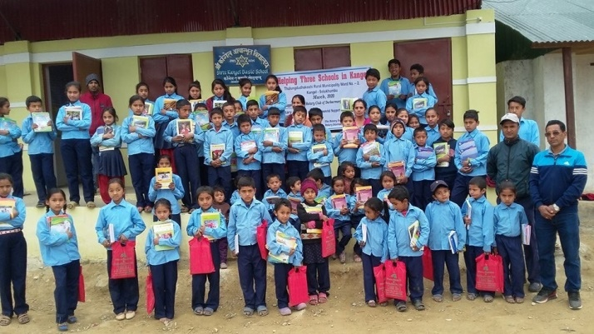

Program

Small group meetings were held at conclusion of full meeting

Powerball Confectionary Challenge –
Wk 1 - No 7 - Graeme Wise Wk 2 - No 20 – Jan Ward Wk 3 No 18 – Bruce Van Every Wk 4 No 11 – Caroline & Rae Wk 5 - No 18 – Bruce VE Wk 6 – No 2 – Andrew Jeffrey
Wk 7 – No 10 – Sue VE Week 8 - No 10 – Sue VE Wk 9 – No 15 – Colin Harding
Wk 10 – No 4 – Catherine E Week 11 - to be announced next week

Foundation Flutter – Caroline basking in the glory of the stunning success of the Quince paste, this weeks flutter was fig based paste
Heads and Tails won by Sue Harrold

Upcoming meetings
June 1 ZOOM meeting
June 8 Public Holiday – No Meeting
June 15 ZOOM meeting

President: Bruce Van Every Secretary: Caroline Rickard
Mob: 0409 149 025 Mob: 0408 989 221
Email: Vanevery4@telstra.com Email: caroliner.drysdale@ijh.com.au
Duty Roster Not required for a little while
Guest Speaker Liaison | WELCOME H/Tails | Attendance | Room set up/pack up | Sergeant

Community News and Important Dates

- RI World Convention
  - Convention is on from 20-26 June as an online event. This format gives many Rotarians to experience a world convention for the first time

- District Changeover
  - District changeover is an online event scheduled for 28 June

- RC Drysdale Garage Sale
  - A Garage Sale will take place later in the year for fund raising. Save up all your items. Storage available at Van Everys.

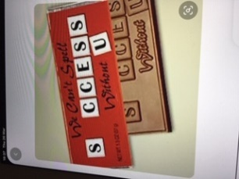

Australian Rotary Health Lift the Lid on Mental Illness/Drysdale RC Fundraiser

The good news is that this fundraiser is super simple. It can be done from the comfort of our homes during isolation.

We are selling Clue Detective online puzzle memberships.

For every Clue Detective subscription, we sell, we receive $24.00.
- $12 for our own club projects
- $12 for Australian Rotary Health’s Lift the Lid on Mental Illness campaign to raise funds for vital mental health research.
- We are asking all members to sell at least 4 memberships for us. Feel free to sell more if you have got a queue of keen puzzlers lined up!

Tips for selling your subscriptions
- Each fundraising subscription sells for $59.95 pa
- Sell to family members, colleagues, friends or neighbours
- If you know an organisation (e.g. public library, retirement village) who would like to purchase a group membership, this can also be arranged. The good news is the amount you raise will be higher.
- You may also know of another organisation who wishes to run a similar fundraiser, please feel free to refer them. Our club will receive a further percentage.
- The member who sells the most memberships will win a great (locally sourced) prize.

Please return your form to<Rotarian Fundraising Coordinator> no later than 14 June 2020.

If you are finding it hard to sell your puzzle memberships, please let me know, other people may be able to help. If you discover a creative way to sell memberships, it would be great if you could share with other members.

We are confident that this fundraising drive will help us reach our target of $2400. This will contribute $1200 to Rotary Club of Drysdale projects and $1200 to Australian Rotary Health’s Lift the Lid on Mental Illness.

